PT 8612
HD-SD Serial digital Test signal Generator

Addendum to installation procedure.

The master PROM with code number 4008 002 08071 has a bug.

The effect is that is some configurations the PT5300 doesn’t remember the settings of the HD-generator when switching off. Also the preset function is not working properly.

These bugs have been fixed in the new version: 4008 002 08072.
The PT5300 will now display Vers. 3.5 at power up.

Please note that very first power-up after replacement of master PROM will exhibit RAM check error.
Therefore make an extra switch off/on sequence.
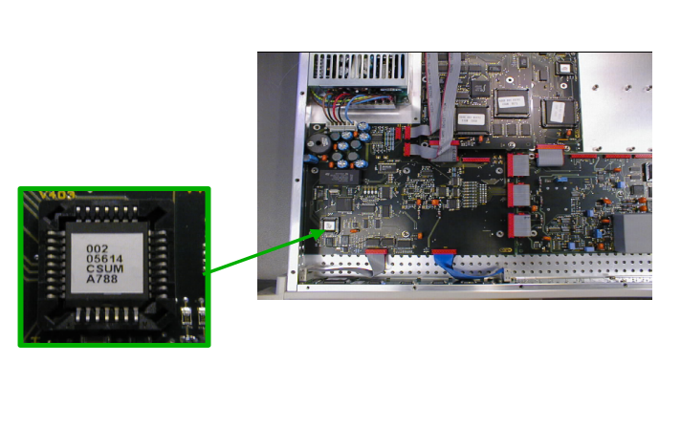
The positioning of the master processor PROM. The lower right corner on the PROM is indicated by a cut in the chip. (Note, that code number on actual PROM may differ from Photo)

